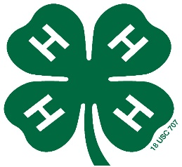
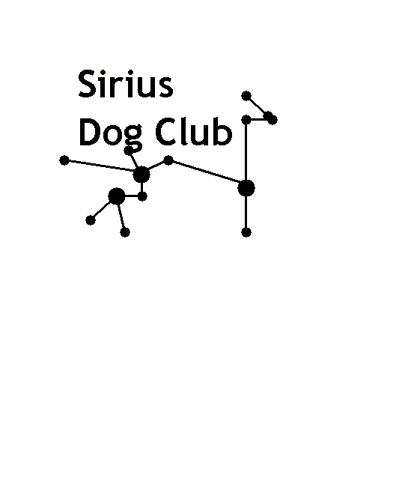
2018 Reno County
4-H Invitational Dog Show
Obedience, Showmanship
Rally-Obedience & Agility
State Fair Qualifying Show

Saturday, June 2, 2018
Registration must be postmarked by May 24th, 2018
Entries with late fee postmarked by May 29th will be excepted - No Day of Show Entries
Show Time 8:00 am (Check -in from 7:15 - 7:45, doors open at 7:00 am)
Sunflower South Building, KS State Fairgrounds
2000 N. Poplar St.
Hutchinson, KS 67502
**Fully Matted Indoor Facility**
Concessions will be available on site for Breakfast & Lunch
Rules:
1. Any 4-Her enrolled in the 2017-2018 4-H Dog Project may compete.
2. All current Kansas 4-H dog rules will apply to this competition.
3. A copy of the completed and signed Blue State 4-H Dog Show Immunization Record must be included with registration.
4. Dogs in season may not be shown and must leave the grounds.
5. No one but the 4-Her is allowed to handle, groom or exercise the dog on the show grounds.
6. In obedience, a dog may be entered in only one class. All classes are open to mixed breeds and purebreds.
7. Baiting of dog with food, clickers or squeakers is not allowed in the ring.
8. Dogs must be kept on leash at all times except when competing in “off leash” competition.
9. 4-Her is responsible for cleaning up after dog, trashcans will be provided outside for dog waste.
Please do not bring into the building.
10. Any dog with a contagious, communicable or infectious disease or condition, as determined by the show superintendents or judge, cannot be shown. The dog must be removed from the show grounds immediately.
11. Any individuals exhibiting unsportsmanlike behavior, any dog that attacks another dog and any person found abusing dogs anywhere on site, will be asked to leave.
12. The Sirius 4-Her Dog Club, Hutchinson Kennel Club, and K-State Research & Extension - Reno County, and the KSF Grounds or any member of said organizations will not be responsible for any loss, theft, injury, or death of dogs entered in the show or for exhibitor injury.

Schedule:

7:00 am Building Open
7:15 to 7:45 Check In
8:00 am Showmanship (Ring 1and 2) & Rally Obedience (Ring 3)
Obedience (Ring 1 and 2) Following showmanship
1:00 pm (or after the completion of Obedience & Rally Obedience)
Agility 2 Trial 1&2
Agility 3 Trial 1&2
Agility 1 Trial 1&2

Contact Ruth Battey, Show Superintendent, at 620-664-8881 ok to text
if you have any questions.

Mail, along with registration 2018 Reno County
and proof of vaccination 4-H Invitational Dog Show
(copy of Blue Card) to Agility, Obedience, Showmanship, Rally Obedience
Registration Form
Ruth Battey
2435 23rd Rd Entry fee is $8.00 per dog per event, if postmarked by May 24th, 2018
Sterling, Ks 67579 Entry fee with late fee $14.00 per dog per event if postmarked by
May 29th, 2018. No day of show entries.
Make checks payable to: Reno Co. 4-H Sirius Dog Club.

Name:_________________________________ Address:______________________________________

4-H Age (as of Jan. 1st):__________ Phone #: __________________ Email:_______________________

1st Dog’s Name:____________ Breed: __________ Dog’s Age:______ Dog’s Ht at Withers:_________
2nd Dog’s Name:___________ Breed:___________ Dog’s Age:______ Dog’s Ht at Withers:_________ 3rd Dog’s Name:____________ Breed:___________ Dog’s Age:______ Dog’s Ht at Withers:_________

I, ____________________________(4-Her) agree to the rules of this show.

I, ____________________________(Parent/guardian) agree to the rules of this show.

