

Reno County
4-H Ambassador Application

To be considered for this position, you must complete and turn in the following items to the Extension Office:
  - Completed Ambassador Application
  - A one page essay of what 4-H has done for you.
  - Completed and signed Ambassador Commitment Form.
  - One letter of reference from your 4-H Club Leader
  - Must be a Freshman, Sophomore, or Junior in High School

Name __________________________________ Club ______________________________

Address ____________________________________________________________________

City _________________________________ State ______ Zip _______________________

School ___________________________________________ Year in School _____________

Phone Number _________________________ Years in 4-H ________________

Parent or Guardian’s Name _____________________________________________________

1. Please list 4-H offices held and committees served on:

2. Please list public relations/communications/presentation experiences:

3. Please list leadership and citizenship experiences:

4. Why do want to be a 4-H Ambassador?

5. Please list other activities you are involved in (school groups, church, community, etc.):

Reno County 4-H Ambassador
Commitment Form

I have reviewed the Ambassador job description. I understand that being a 4-H Ambassador is a 2 year commitment. I also understand that the following will be expected of me:

1. Actively participate in Ambassador projects and meetings.
2. Attend at least 75% of Ambassador meetings.
3. Enthusiastically promote the Reno County 4-H program.
4. Take ownership of the Ambassador position and make it the best it can be.

If I am unable to fulfill my commitment to the Ambassador program, I will discuss the situation with my Ambassador advisors. I understand that the advisors will reserve the right to dismiss any member not fulfilling their responsibilities.

Applicant Signature: ___________________________________________ Date: _____________

We (I) understand that my son/daughter wishes to be a Reno County 4-H Ambassador. We (I) will support him/her in fulfilling the responsibilities should he/she be selected.

Parent/Guardian Signature: ______________________________________ Date: _____________

I confirm that the above named 4-H’er is enrolled, active, and in good standing in the club 4-H Program. I support his/her application for the position of Reno County 4-H Ambassador.

Club Community
Leader Signature: _____________________________________________ Date: _______________

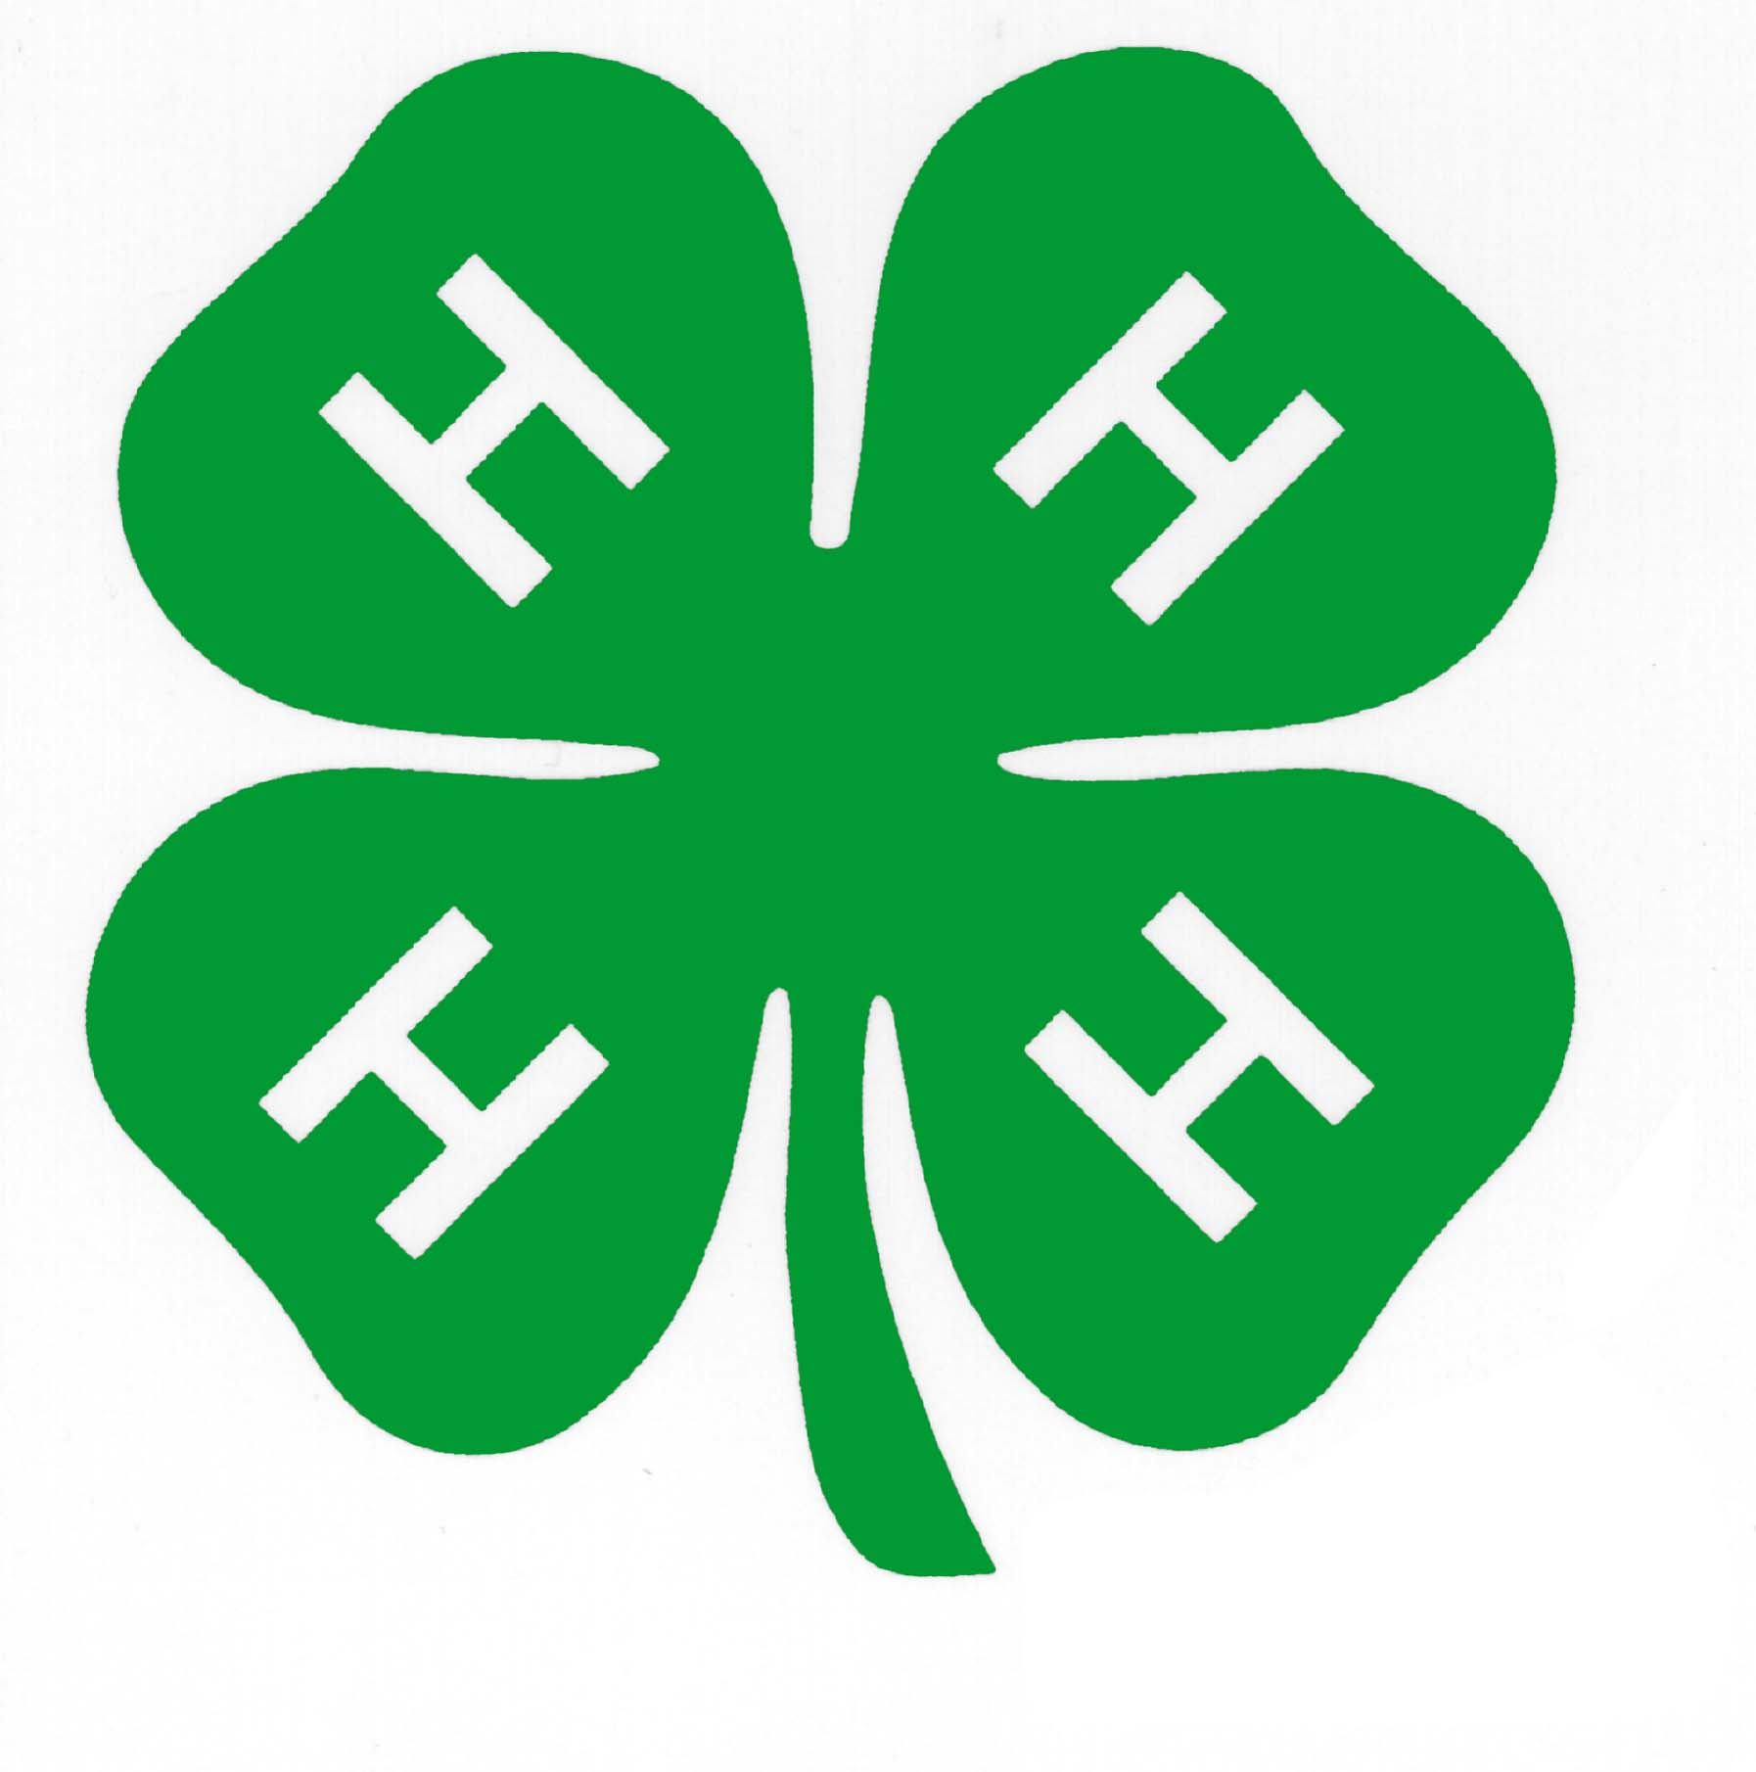

K-State Research & Extension – Reno County
2 W. 10th, South Hutchinson, KS 67505
620-662-2371 fax 620-662-0313
Email: rn@oznet.ksu.edu

