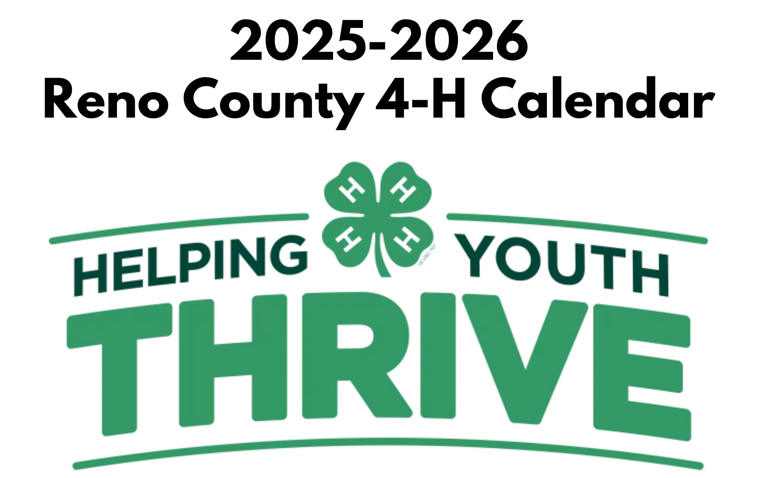

 |  | October 2025
Sunday | Monday | Tuesday | Wednesday | Thursday | Friday | Saturday
 |  |  | 1 | 2 | 3 | 4
 |  |  | Enrollment Opens |  | Record Books Due to the office  All club paperwork due to office
5 | 6 | 7 | 8 | 9 | 10 | 11
National 4-H Week |  |  | Fair Board |  |  | 48 Hours of 4-H
12 | 13 | 14 | 15 | 16 | 17 | 18
Ninnescah  Thomadora  Union Valley  WRC  48 Hours of 4-H | Buhler  Columbus Day (office closed)
19 | 20 | 21 | 22 | 23 | 24 | 25
Haven
Mitchell
Nickerson
26 | 27 | 28 | 29 | 30 | 31
 | 4-H Council |  |  |  | Halloween
 |  | November 2025
Sunday | Monday | Tuesday | Wednesday | Thursday | Friday | Saturday
 |  |  |  |  |  | 1
2 | 3 | 4 | 5 | 6 | 7 | 8
9 | 10 | 11 | 12 | 13 | 14 | 15
Achievement Night, 3 PM  Ninnescah  Thomadora  Union Valley  WRC | Buhler | Veteran’s Day  Office Closed | Fair Board
16 | 17 | 18 | 19 | 20 | 21 | 22
Haven  Mitchell  Nickerson |  |  | Cookie Dough Forms due to Extension Office |  |  | KYLF
23 | 24 | 25 | 26 | 27 | 28 | 29
KYLF |  |  |  | Thanksgiving  Office Closed | Office Closed

 |  | December 2025
Sunday | Monday | Tuesday | Wednesday | Thursday | Friday | Saturday
Nov 30 | 1 | 2 | 3 | 4 | 5 | 6
 |  |  | New Member Meeting 6 PM
7 | 8 | 9 | 10 | 11 | 12 | 13
 | Buhler |  | Fair Board |  | Cookie Dough Pick-up Extension Office Basement Time TBA
14 | 15 | 16 | 17 | 18 | 19 | 20
Ninnescah
Thomadora
Union Valley
WRC
21 | 22 | 23 | 24 | 25 | 26 | 27
Haven  Mitchell  Nickerson |  |  | Christmas Eve  Office Closed | Christmas  Office Closed | Office Closed
28 | 29 | 30 | 31
 | Office Closed | Office Closed | Office Closed

 |  | January 2026
Sunday | Monday | Tuesday | Wednesday | Thursday | Friday | Saturday
 |  |  |  | 1 | 2 | 3
 |  |  |  | New Year’s Day Office Closed
4 | 5 | 6 | 7 | 8 | 9 | 10
 |  |  |  | Public Speaking Workshop 6 PM
11 | 12 | 13 | 14 | 15 | 16 | 17
Ninnescah  Thomadora  Union Valley  WRC | Buhler |  | Fair Board
18 | 19 | 20 | 21 | 22 | 23 | 24
Haven  Mitchell  Nickerson | Martin Luther King, Jr, Day  Office Clsoed
25 | 26 | 27 | 28 | 29 | 30 | 31
 | 4-H Council

 |  | February 2026
Sunday | Monday | Tuesday | Wednesday | Thursday | Friday | Saturday
1 | 2 | 3 | 4 | 5 | 6 | 7
8 | 9 | 10 | 11 | 12 | 13 | 14
Ninnescah  Thomadora  Union Valley  WRC | Buhler |  | Fair Board |  | Deadline to sign up for 4-H Days | Valentine’s Day
15 | 16 | 17 | 18 | 19 | 20 | 21
CIA  Haven  Mitchell  Nickerson | President’s Day  Office Closed  CIA |  |  |  |  | 4-H Days
22 | 23 | 24 | 25 | 26 | 27 | 28
 | 4-H Council |  |  |  | Household Nominations due to office

 |  | March 2026
Sunday | Monday | Tuesday | Wednesday | Thursday | Friday | Saturday
1 | 2 | 3 | 4 | 5 | 6 | 7
 |  |  |  |  |  | Beef Tagging (Family)
8 | 9 | 10 | 11 | 12 | 13 | 14
Buhler  Ninnescah  Thomadora  Union Valley  WRC |  |  | Fair Board
15 | 16 | 17 | 18 | 19 | 20 | 21
Haven  Mitchell  Nickerson |  |  |  |  | Livestock Sale scholarship due to office by 5 PM
22 | 23 | 24 | 25 | 26 | 27 | 28
Family Fun Night, 2-5 PM
29 | 30 | 31

 |  | April 2026
Sunday | Monday | Tuesday | Wednesday | Thursday | Friday | Saturday
 |  |  | 1 | 2 | 3 | 4
5 | 6 | 7 | 8 | 9 | 10 | 11
Easter Sunday |  |  | Fair Board
12 | 13 | 14 | 15 | 16 | 17 | 18
Ninnescah  Thomadora  Union Valley  WRC | Buhler |  |  |  |  | Spring State Shooting Sports Match
19 | 20 | 21 | 22 | 23 | 24 | 25
Haven  Mitchell  Nickerson |  |  |  |  | Small animal tag numbers due to the office
26 | 27 | 28 | 29 | 30
 | 4-H Council | State YEC | State YEC

 |  | May 2026
Sunday | Monday | Tuesday | Wednesday | Thursday | Friday | Saturday
 |  |  |  |  | 1 | 2
 |  |  |  |  | Add/Drop Deadline  Dog & Horse ID due to the office | Small animal tagging (family)
3 | 4 | 5 | 6 | 7 | 8 | 9
10 | 11 | 12 | 13 | 14 | 15 | 16
Mother’s Day  Thomadora | Buhler |  | Fair Board
17 | 18 | 19 | 20 | 21 | 22 | 23
Haven
Ninnescah
Mitchell
Nickerson
Union Valley
WRC
24 | 25 | 26 | 27 | 28 | 29 | 30
Memorial Day
Office Closed

 |  | June 2026
Sunday | Monday | Tuesday | Wednesday | Thursday | Friday | Saturday
May 31 | 1 | 2 | 3 | 4 | 5 | 6
 | Fair Entry Opens |  | Discovery Days | Discovery Days | Discovery Days
7 | 8 | 9 | 10 | 11 | 12 | 13
 |  | Wild Horse 4-H Camp | Fair Board  Wild Horse 4-H Camp | Wild Horse 4-H Camp | State Geology Field Trip | State Geology Field Trip
14 | 15 | 16 | 17 | 18 | 19 | 20
Buhler  Haven  Mitchell  Ninnescah  Nickerson  Thomadora  Union Valley  WRC |  |  |  |  | Juneteenth  (Office Closed)
21 | 22 | 23 | 24 | 25 | 26 | 27
Father’s Day | 4-H Council
28 | 29 | 30

 |  | July 2026
Sunday | Monday | Tuesday | Wednesday | Thursday | Friday | Saturday
 |  |  | 1 | 2 | 3 | 4
 |  |  | Fair Entry closes |  |  | Independence Day
5 | 6 | 7 | 8 | 9 | 10 | 11
 |  |  | Fair Board
12 | 13 | 14 | 15 | 16 | 17 | 18
 | Fair entry card pick-up (static only) | Fair entry card pick-up (static only)  Livestock Sale Calling | Fair entry card pick-up (static only) | Fair entry card pick-up (static only)  Livestock Sale Calling | Fair entry card pick-up (static only)  Fashion Revue Paperwork Due | Dog Show
19 | 20 | 21 | 22 | 23 | 24 | 25
 |  |  | Fair | Fair | Fair | Fair
26 | 27 | 28 | 29 | 30 | 31
Fair | Fair

 |  | August 2026
Sunday | Monday | Tuesday | Wednesday | Thursday | Friday | Saturday
 |  |  |  |  |  | 1
2 | 3 | 4 | 5 | 6 | 7 | 8
 |  |  |  |  | State fair entry paperwork due to the office
9 | 10 | 11 | 12 | 13 | 14 | 15
Buhler  Ninnescah  Thomadora  Union Valley  WRC |  |  | Fair Board |  |  | State Horticulture Judging
16 | 17 | 18 | 19 | 20 | 21 | 22
Haven
Mitchell
Nickerson
23 | 24 | 25 | 26 | 27 | 28 | 29
 | 4-H Council
30 | 31

 |  | September 2026
Sunday | Monday | Tuesday | Wednesday | Thursday | Friday | Saturday
 |  | 1 | 2 | 3 | 4 | 5
 |  |  |  | Record Book Workshop, 6:30 PM
6 | 7 | 8 | 9 | 10 | 11 | 12
 | Labor Day  Office Closed |  | Fair Board | State fair entries received at the fairgrounds | Kansas State Fair | Kansas State Fair
13 | 14 | 15 | 16 | 17 | 18 | 19
Ninnescah  Thomadora  Union Valley  WRC  Kansas State Fair | Buhler  Kansas State Fair | Kansas State Fair | Kansas State Fair | Kansas State Fair | Kansas State Fair | Kansas State Fair
20 | 21 | 22 | 23 | 24 | 25 | 26
Haven  Mitchell  Nickerson  Kansas State Fair | State fair entries must be picked up by 10 AM |  |  |  |  | State Archery Match
27 | 28 | 29 | 30
 |  | October 2026
Sunday | Monday | Tuesday | Wednesday | Thursday | Friday | Saturday
 |  |  |  | 1 | 2 | 3
 |  |  |  | Enrollment Opens | Record Books due to office  All club paperwork due to office
4 | 5 | 6 | 7 | 8 | 9 | 10
11 | 12 | 13 | 14 | 15 | 16 | 17
Ninnescah  Thomadora  Union Valley  WRC | Buhler  Columbus Day  Office Closed |  | Fair Board
18 | 19 | 20 | 21 | 22 | 23 | 24
Haven
Mitchell
Nickerson
State Shotgun Match
25 | 26 | 27 | 28 | 29 | 30 | 31
 |  |  |  |  |  | Halloween

